**DEEP LEARNING**

## LAB ASSIGNMNET – 3

**NAME: HARIKA ADIVANNE**

**CLASS ID: 02**

**INTRODUCTION:**

In this assignment the main focus to implement text classification with CNN model, RNN model and LSTM model with new data set and observe to analyze the results.

**Objective:**

The key objective here is to implement text classification with CNN model, RNN model and LSTM model and plotting the graph in tensor board to observe the results of changed parameters and analyze the accuracy and loss based on the iterations.

**METHODS:**

**CNN:**

Here I have implement CNN model by considering the data with different classes. Initialized training and the network parameters. Output is plotted as graph and the results such as accuracy and loss has been analyzed by the training data.

**RNN:**

Here I have implement RNN model by considering the data with different classes. Initialized training and the network parameters and evaluated model. Output is plotted as graph and the results such as accuracy and loss has been analyzed by the training data.

**LSTM:**

Here I have implement LSTM model by considering the data with different classes. Initialized training and the network parameters and evaluated model and also used Gradient Descent as optimizer. Output is plotted as graph and the results such as accuracy and loss has been analyzed by the training data.

# WORKFLOW

* Installed required packages
* Applied CNN
* Applied RNN
* Applied LSTM
* Initialized variables
* Divided into training and testing
* Used parameters for prediction
* Calculated loss
* Calculated accuracy

**DATASETS:**

Data set is used to implement the CNN, RNN and LSTM models. This dataset has different classes in it to predict the accuracy and loss

**PARAMETERS:**

Learning rate

Batch size

No. of steps

**EVALUATION:**

**Source code:**

**CNN:**

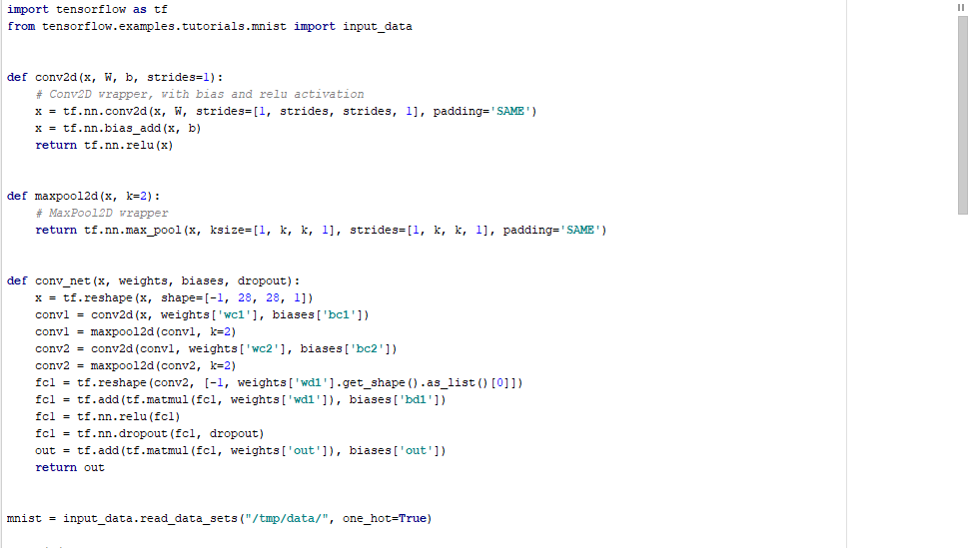

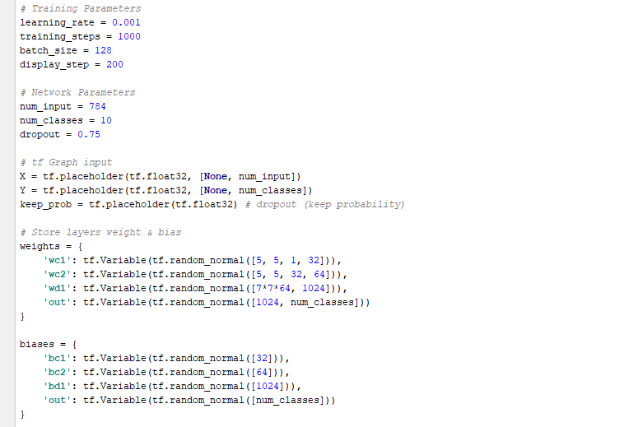

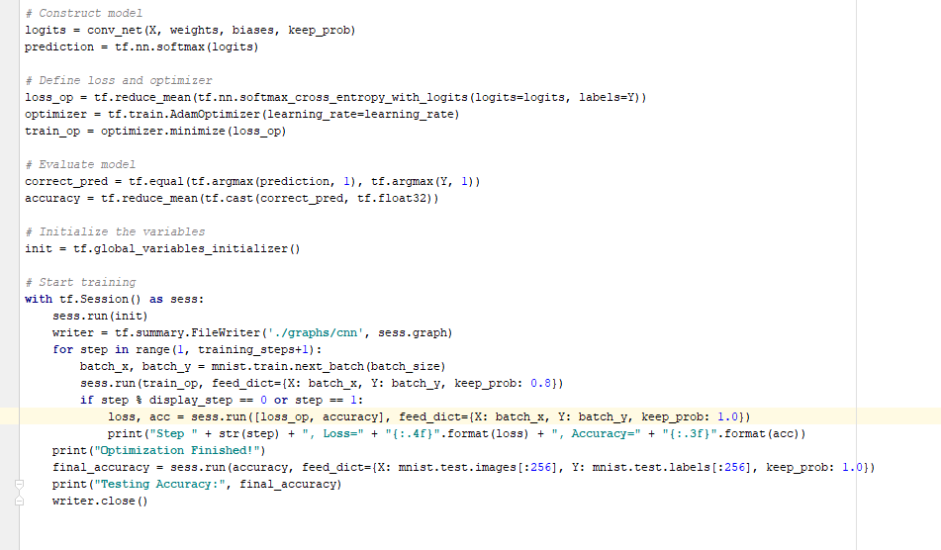

RNN:

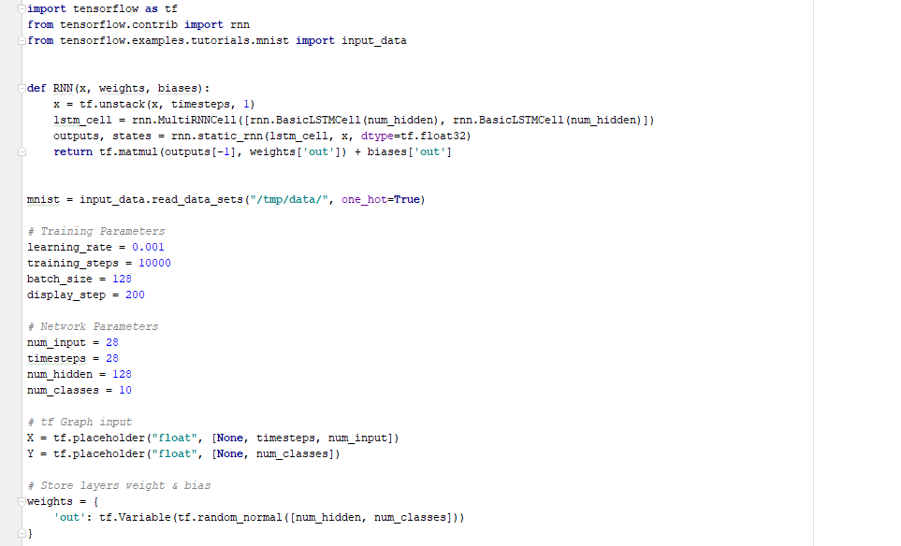

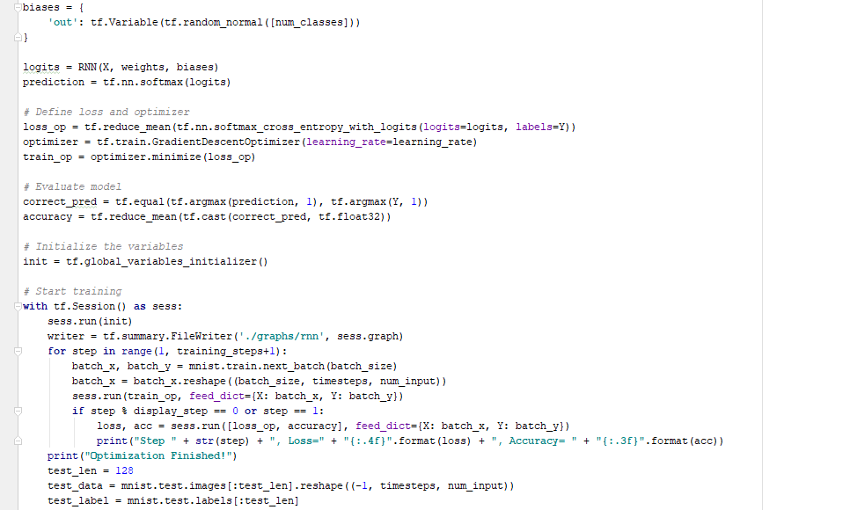

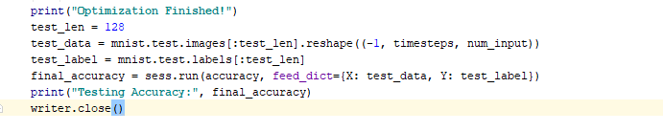

LSTM:

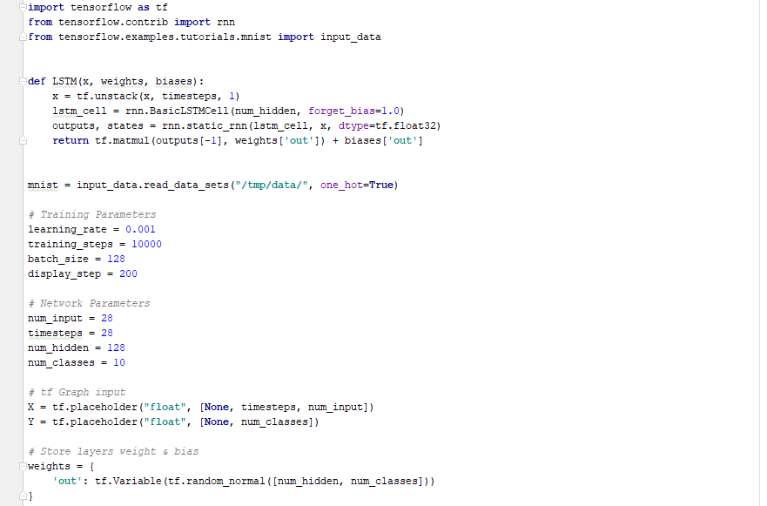

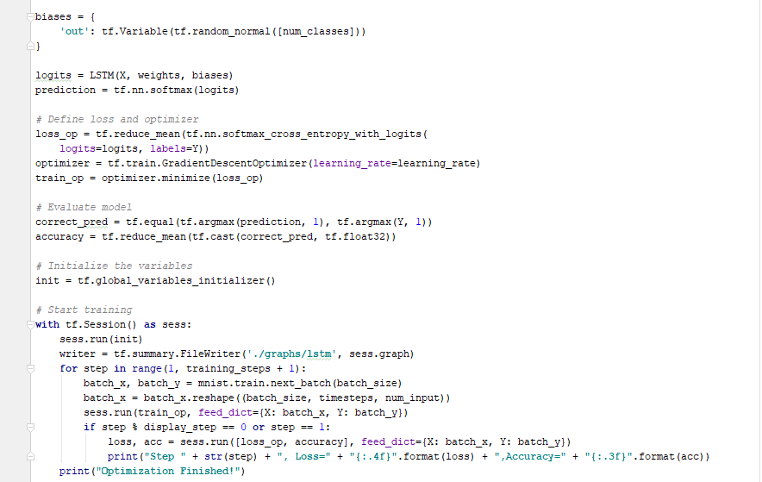

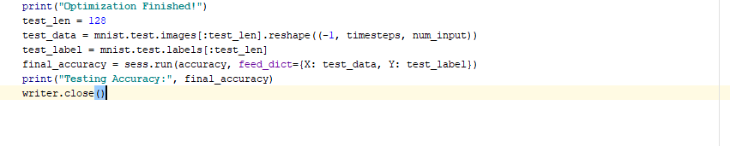

**OUTPUT:**

**CONCLUSION:**

Here from the above observation I conclude that CNN has high accuracy and loss but if there is change in hyper parameters or network parameters there will be an increase in other models. Therefore for more number of steps I conclude LSTM ids better than accuracy.